**SYNOPSIS**

# ONLINE HOTEL MANAGEMENT SYSTEM

###### SUBMITTED BY:

**NAME: ENROLLMENT NO:**

(Dynamic Site using JSP, SERVLETS and My SQL )

**ONLINE HOTEL MANAGEMENT SYSTEM**

**Under Supervision of :**

**Submitted By:**

Name :

Address :

Phone No :

Programme : .

Enrolment No. :

**ONLINE HOTEL MANAGEMENT SYSTEM**

### Table of Contents

Title of the project.

Introduction and objectives of the Project. Project category.

Analysis (DFDs, ER Diagrams, Class Diagrams etc.) A complete structure Which includes :

1. Number of modules and their description to provide an estimation of the student’s effort on the project.
2. Data Structures as per the project requirements for all the modules.
3. Process Logic of each module.
4. Report generation.

Tools / Platform, Hardware and Software Requirement specification Security and Validation Checks.

Scope of future application. Conclusions

Bibliography

# ONLINE HOTEL MANAGEMENT SYSTEM

#### 1.1 INTRODUCTION

This is a Project work undertaken in context of partial fulfillment of MCA.I have tried my best to make the complicated process of Online Hotel Management System as simple as possible using Structured & Modular technique & Menu oriented interface. I have tried to design the software in such a way that user may not have any difficulty in using this package & further expansion is possible without much effort. Even though I cannot claim that this work to be entirely exhaustive, the main purpose of my exercise is perform each Employee’s activity in computerized way rather than manually which is time consuming.

I am confident that this software package can be readily used by non-programming personal avoiding human handled chance of error. This project is used by two types of users

1. Online Users.
2. Administrator (management of the Hotel). Online users can see the required articles or news

Administrator can maintain daily updates in the hotel records. Administrator is must be an authorized user. He can further change the password. There is the facility for password recovery, logout etc.

The main aim of the entire activity is to automate the process of day to day activities of Hotel like Room activities, Admission of a New Customer, Assign a room according to customer’s demand, checkout of a computer and releasing the room and finally compute the bill etc.

The limited time and resources have restricted us to incorporate, in this project, only a main activities that are performed in a HOTEL Management System, but utmost care has been taken to make the system efficient and user friendly. “HOTEL Management System” has been designed to computerized the following functions that are performed by the system:

Room Detail Functions Opening a New Room

Modification to room assigned Check-in and check-out Detail Functions

Admission of New customer Check-out of customer

Room assigning related to customer’s need.

Statement of Customer Details Check-in customer Check-out customer Room Details

Total number of Customers in the Hotel Individual customer Report

**OBJECTIVE**

During the past several decades personnel function has been transformed from a relatively obscure record keeping staff to central and top level management function. There are many factors that have influenced this transformation like technological advances, professionalism, and general recognition of human beings as most important resources.

* A computer based management system is designed to handle all the primary information required to calculate monthly statements. Separate database is maintained to handle all the details required for the correct statement calculation and generation.
* This project intends to introduce more user friendliness in the various activities such as record updation, maintenance, and searching.
* The searching of record has been made quite simple as all the details of the customer can be obtained by simply keying in the identification of that customer.
* Similarly, record maintenance and updation can also be accomplished by using the identification of the customer with all the details being automatically generated. These details are also being promptly automatically updated in the master file thus keeping the record absolutely up-to-date.
* The entire information has maintained in the database or Files and whoever wants to retrieve can’t retrieve, only authorization user can retrieve the necessary information which can be easily be accessible from the file.
* The main objective of the entire activity is to automate the process of day to day activities of Hotel like:
  1. Room activities,
  2. Admission of a New Customer,
  3. Assign a room according to customer’s demand,
  4. Checkout of a computer and releasing the room
  5. Finally compute the bill etc.
  6. Packages available.
  7. Advance online bookings.
  8. Online Cancellation.
  9. List of Regular customers.
  10. Email facility.
  11. Feedbacks

This project have some more features:

* System Connectivity
* No data duplication
* No Paper Work Required
* Time Efficient
* Cost Efficient
* Automatic data validation
* User friendly environment
* Data security and reliability
* Fast data insertion & retrieval
* Easy performance check

#### ADVANTAGE:

I have designed the given proposed system in the JSP to automate the process of Hotels. This project is useful for the authorities which keep track of all the users registered in a particular state .The authority can add hotel packages, room details, availability of rooms, online booking etc.

The following steps that give the detailed information of the need of proposed system are:

**Performance:** During past several decades, the records are supposed to be manually handled for all activities. The manual handling of the record is time consuming and highly prone to error. To improve the performance of the Hotel Management System, the computerized system is to be undertaken. This project is fully computerized and user friendly even that any of the members can see the report and status of the company.

**Efficiency:** The basic need of this website is efficiency. The website should be efficient so that whenever a new user submits his/her details the website is updated automatically. This record will be useful for other users instantly.

**Control:** The complete control of the project is under the hands of authorized person who has the password to access this project and illegal access is not supposed to deal with. All the control is under the administrator and the other members have the rights to just see the records not to change any transaction or entry.

**Security:** Security is the main criteria for the proposed system. Since illegal access may corrupt the database. So security has to be given in this project.

#### PROJECT CATEGORY

This Project is coupled with material on how to use the various tool, sub sets available in JSP, SERVLETS AND MY SQL.

The need of today’s software development is competence in a GUI based front-end tool, which can connect to Relational Database engines. This gives the programmer the opportunity to develop client server based commercial applications.

These applications give users the power and ease of a GUI with the multi user capabilities of Novell, UNIX or WinNT based RDBMS engines such as MY SQL .

All the important coding techniques used by programmers, in OOPS based coding is brought out in full and in great detail.

#### System Study & Analysis

**PRINCIPLES OF SYSTEM ANALYSIS**

1. Understand the problem before you begin to create the analysis model.
2. Develop prototypes that enable a user to understand how human machine interaction will occur.
3. Record the origin of and the reason for every requirement.
4. Use multiple views of requirements like building data, function and behavioral models.
5. Work to eliminate ambiguity.

###### ENTITY RELATIONSHIP DIAGRAM (ERD)

**Entity – Relationship Diagram:** This depicts relationship between data objects. The attribute of each data objects noted in the entity- relationship diagram can be described using a data object description. Data flow diagram serves two purposes:

1. To provide an indication of how data are transformed as they move through the system.
2. To depict the functions that transformation the data flow.

**Data Objects:** A data object is a representation of almost any composite information that must be understood by the software. By composite information, we mean something that has a number of different properties or attributes. A data object encapsulates data only there is no reference within a data object to operations that act on the data.

**Attributes:** Attributes define the properties of a data object and take on one of three different characteristics. They can be used to:

Name an instance of data object. Describe the instance.

Make reference to another instance in other table.

**Relationships:** Data objects are connected to one another in a variety of different ways. We can define a set of object relationship pairs that define the relevant relationships.

###### CARDINALITY AND MODALITY:

* + **Cardinality:**

**The data model must be capable of representing the number of occurrences of objects in a given relationship. The cardinality of an object relationship pair is**

* + - One-T0-One (1:1): **An occurrence of object ‘A’ can relate to one and only one occurrence of object ‘B’ and vice versa.**
    - One-To-Many (1:N): **One occurrence of object ‘A’ can relate to one or may occurrences of object ‘B’ but an occurrence of object ‘B’ can relate to only one occurrence of object ‘A’.**
    - Many-To-Many (M: N): **An occurrences of ‘B’ and an occurrence of ‘B’ can relate to one or many occurrence of ‘A’.**
  + **Modality:**

###### The modality of a relationship is zero if there is no explicit need for the relationship to occur or the relationship is optional. The Modality is one if the occurrence of the relationship is mandatory.

The object relationship pair can be represented graphically using the Entity Relationship Diagrams. A set of primary components are identified for the Entity Relationship Diagram,

1. **Attributes,**
2. **Relationships and**
3. **Various Type Indicators.**

**The primary purpose of the Entity Relationship Diagram is to represent data objects and their relationships.**

**Checkout**

**Room**

**Customer**

**E-R DIAGRAM**

**Room**

**information**

**Check**

**-in**

**customer**

**Hotel**

**Room**

**Room record**

Customer

**Hotel**

**Bill generation**

**Hotel**

**CONTEXT LEVEL DFD HOTEL MANAGEMENT SYSTEM**

**HOTEL MANAGEMENT SYSTEM**

**PRINT DEVICE**

**CUSTOMER CHECKOUT**

**ROOM**

**CUSTOMER**

**DATA FLOW DIAGRAM OPENING A NEW ROOM**

1 Generating

new room number

1.1 Display

Form

FILE

Process

Update Table

1.2 Get

Details

customer Document

1.4

Update

1.3

Open Room

**CUSTOMER**

**DATA FLOW DIAGRAM CHECK-IN OF A NEW CUSTOMER**

1 Assigning a new room number

**CUSTOMER**

FILE

* 1. Display Form

Process

Update Table

* 1. Get Details

##### Customer Details

1.4

Update

Assigning a Room

**DATA FLOW DIAGRAM RECORD MODIFICATION**

1

Read the customer room number

Scan Record

2

Show the Details of Record

FILE

Processing

Update

3

Modify Details of Record

**USER**

**DATA FLOW DIAGRAM CHECK-OUT OF CUSTOMER**

1 Scan the customer room number

**CUSTOMER**

##### FILE

* 1. Display Form

Update Table

Process

##### Customer Details

1.4

Update

* 1. Get Details

**OUTPUT UNIT**

## DATA FLOW DIAGRAM LISTING OF CUSTOMERS

FILE

Scan Record

1 Read the

room number

2 Select

Record from Database

3 Copy

Selected Record

Processing

6 Copy

Selected Record

4

Compute Total

Processing

Output

5 Select

Record

7

Compute Bill

8

Generate Total List

Final Output

To Screen/Printer

**CUSTOMER**

**DATA FLOW DIAGRAM GENERATING BILL OF CUSTOMER**

**CUSTOMER**

FILE

Scan RoomNo

1

Read room number

2 Check for

check out of customer

Update

Processing

4

Close Database

3

Compute Bill

Cash

**MANAGE EMENT**

**DATA FLOW DIAGRAM LIST OF ALL RECORDS**

FILE

Scan All Record

1

Read the Request

2 Select

Record from File

Processing

3 Copy

Selected Record

7 Copy

Selected Record

4

Compute Total

Processing

5

Select Record

Output

7

Compute bill

8 Generate

Total List

Final Output

To Screen/Printer

**OUTPUT UNIT**

**MANAG EMENT**

###### 4.2 DATA MODELING

Data modeling defines primary data objects, composition of each data object, and attributes of the object, relationships between each object and other objects and between objects and the processes.

###### Password Table

|  |  |
| --- | --- |
| Fields | Type |
| Password | CHAR |
| Username | Number |

**Login Status Table**

|  |  |
| --- | --- |
| Fields | Type |
| Password | CHAR |
| Username | Number |
| Login_time | CHAR |
| Login_date | CHAR |
| Logout_time | CHAR |
| Page_access | CHAR |

**Customer Details Table**

|  |  |
| --- | --- |
| Fields | Type |
| customerid | Autonumber |
| Name | CHAR |
| Address | CHAR |
| Email | CHAR |
| DOJ | Date |
| Status | CHAR |
| Occupation | CHAR |
| Type_of_occupation | Number |
| Telephone | Number |

**Member Details Table**

|  |  |
| --- | --- |
| Fields | Type |
| Memberid | Autonumber |
| Name | CHAR |
| Address | CHAR |
| Email | CHAR |
| DOJ | Date |
| Status | CHAR |
| Occupation | CHAR |
| Type_of_occupation | Number |
| Telephone | Number |
| Membership | CHAR |

|  |  |
| --- | --- |
| Details | CHAR |

**Hotel Details Table**

|  |  |
| --- | --- |
| Fields | Type |
| Company_name | CHAR |
| H.o | CHAR |
| Address | CHAR |
| Meeting_person | CHAR |
| Phone | Number |
| Email | CHAR |
| Website | CHAR |
| Details | CHAR |
| No_of_employees | Number |

**Booking Details Table**

|  |  |
| --- | --- |
| Fields | Type |
| Package | CHAR |
| Bookingdate | Date |
| Mode_of_booking | CHAR |
| From | Date |
| To | Date |
| Requirement_details | CHAR |
| State | CHAR |
| Name_of_customer | CHAR |
| Email | CHAR |
| Phone | Number |

**Room Details Table**

|  |  |
| --- | --- |
| Fields | Type |
| Room_No | CHAR |
| Bookingdate | Date |
| Floor |  |
| Package |  |
| Mode_of_booking | CHAR |
| From | Date |
| To | Date |
| Requirement_details | CHAR |
| State | CHAR |
| Name_of_customer | CHAR |
| Email | CHAR |
| Phone | Number |

**Checkout Details Table**

|  |  |
| --- | --- |
| Fields | Type |
| Room_No | CHAR |
| Bookingdate | Date |
| Floor |  |

|  |  |
| --- | --- |
| Package | CHAR |
| Mode_of_Payment | CHAR |
| Checkin_date | Date |
| Checkout_date | Date |
| Checkout_bill_det | CHAR |
| State | CHAR |
| Name_of_customer | CHAR |
| Email | CHAR |
| Phone | Number |

**Package Details Table**

|  |  |
| --- | --- |
| Fields | Type |
| Package_name | CHAR |
| Price | Number |
| From | Date |
| To | Date |
| For_Member_price | Number |
| Details | CHAR |

**Function Details**

The basic objective of **HOTEL MANAGEMENT SYSTEM** is to generalize and simplify the monthly or day to day activities of Hotel like Room activities, Check in of New Customer, Check out of customer, Assigning a room according to customer requirement, and finally compute the bill etc. which has to be performed repeatedly on regular basis. To provide efficient, fast, reliable and user-friendly system is the basic motto behind this exercise.

Let us now discuss how different functions handle the structure and data files:

###### Password

In this module, this website is for multiple users. If a User enters a password and the software checks its validity. If the password is valid then option is given to change the password, otherwise “Invalid

User/Password” message is displayed. There is an option for password recovery, log out, login, new users sign in. The Administrator can also update changes in the site after login.

###### Creating new Entity (Hotel, Room, Customers,Members etc.)

This is used to add a new employee details, delete entity details and view the details. In that screen, the automatic item is created.

In this function, whenever a new entity is required to be added the corresponding forms are opened and the database is manipulated to check whether the data is already existing or not. If it already exists, then it prompts that “Entry already existing” and if not than the data is entered with the various validation checks.

###### Function NEW_ROOM()

This is the function used to open a new room for a customer so that he/she can assign a separate room . In that screen, the automatic room number is created. After opening a new room for the customer, finally a room is assigned to a customer and the room records are appended in the data file.

###### Function CHECKIN_CUSTOMER()

This function is used to admit a customer in our Hotel after entering his all personal details like Name, Address, Phone, Sex and then he/she is assigned a room from NEW_ROOM() function.

###### Function CHECKOUT_CUSTOMER()

This function is used to checkout the customer details from database. When the user inputs his room number, the same room number will be checked in the database, if the room number is matched in the database, then the customer will be check-out from the database and transferred the record of the checkout to another table of database so that the Hotel Management has the record of customers who have check-out to fulfill his legal liabilities.

###### Function GENERATE_BILL()

When any customer check-out, his/her bill is generated automatically by calculated check-out date minus check-in date and getting multiplied it by daily room charge plus other charges and the bill has to be saved in the table in the database.

###### Function DISPLAY_RECORD()

This function is used to display all the transaction including the customer name, address, phone, bed number, and doctor assigned to him/her in the screen. This is a global repor to display all the transaction records in the screen.

###### 8 Validation of Data Entered by the User & Error Handling

In this function, the validity of data entered by the user during the various business processes is checked through various validation checks. For example, there should not be any characters entered in the numeric fields, likewise if there is any error occurs than it should handle that particular error and give the required messages.

###### 10 Searching

In this function, room, customer well as members can search details from the database according to their authentications.

###### 11: Report Generation

In this function reports are generated for the following entities:

1. Customer Details.
2. Requirements of the Customers
3. Rooms Details
4. Bill Details
5. Checkin Reports
6. Booking Details
7. Online Bookings
8. Checkout Details
9. Membership Details
10. Packages Available.

**Scope of Future Application**

This project can be used in the hotel after adding some more useful modules in the project for which hotel are providing services.

Utmost care and back-up procedures must be established to ensure 100% successful implementation of the computerized hotel system. In case of system failure, the organization should be in a position to process the transaction with another organization or if the worst comes to the worst, it should be in a position to complete it manually.

#### Scope of Improvement

Now a days hotel are providing many other facilities, this project can also be improved with the improvement in the Hotels.

Utmost care and back-up procedures must be established to ensure 100% successful implementation of the computerized banking system. In case of system failure, the organization should be in a position to process the transaction with another organization or if the worst comes to the worst, it should be in a position to complete it manually.

**ScreenShort**

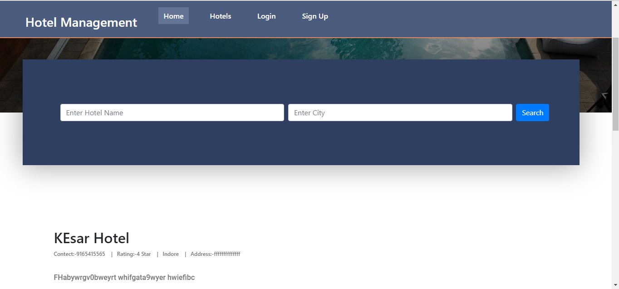

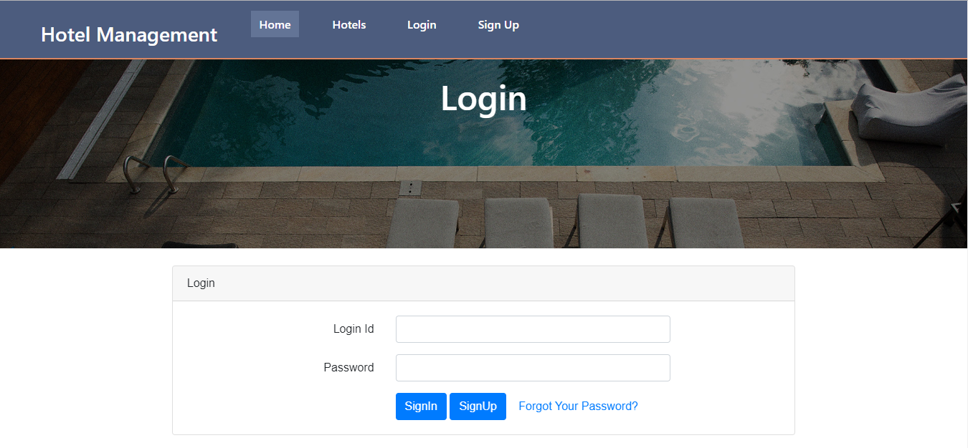

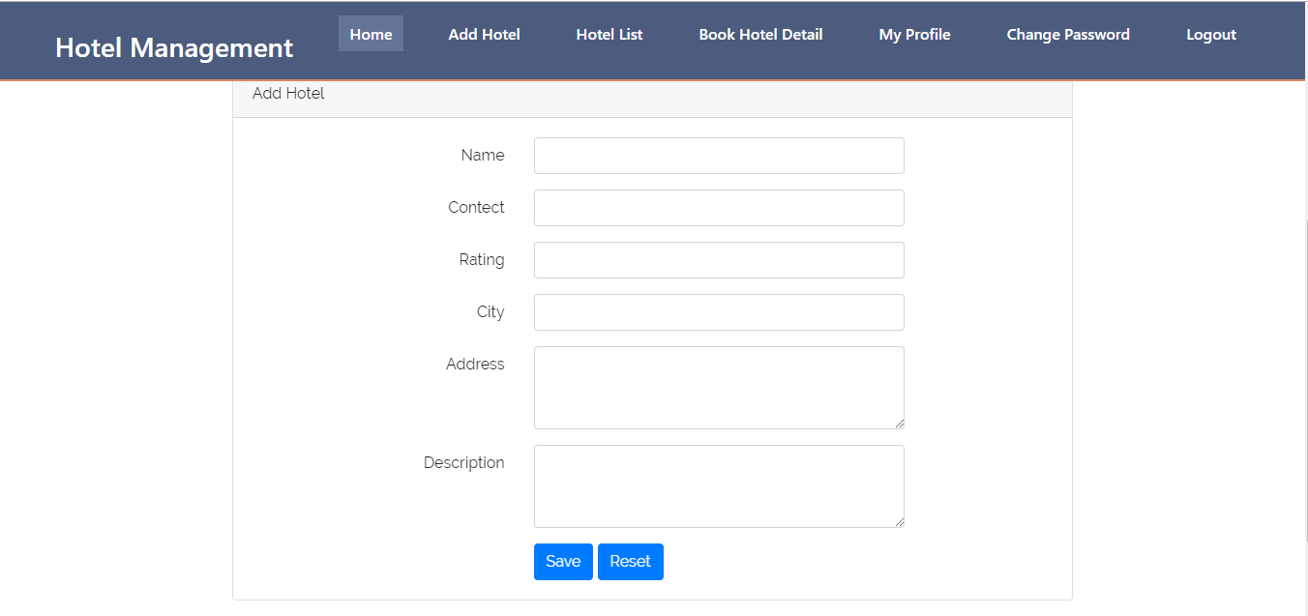

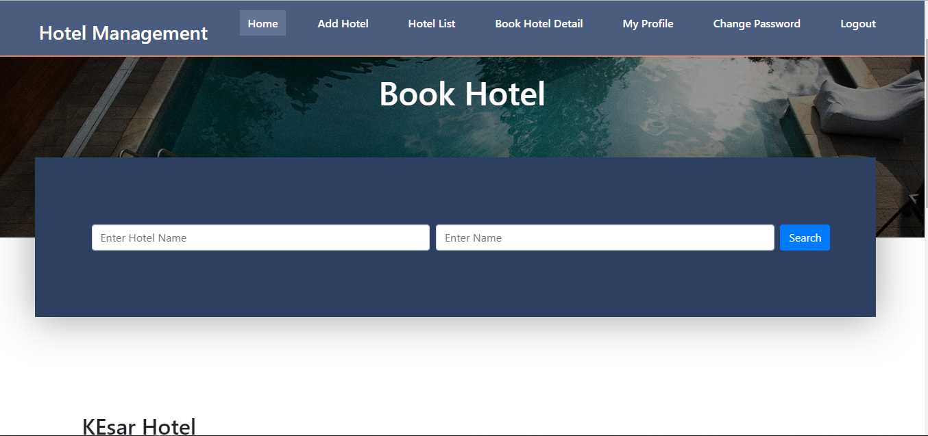

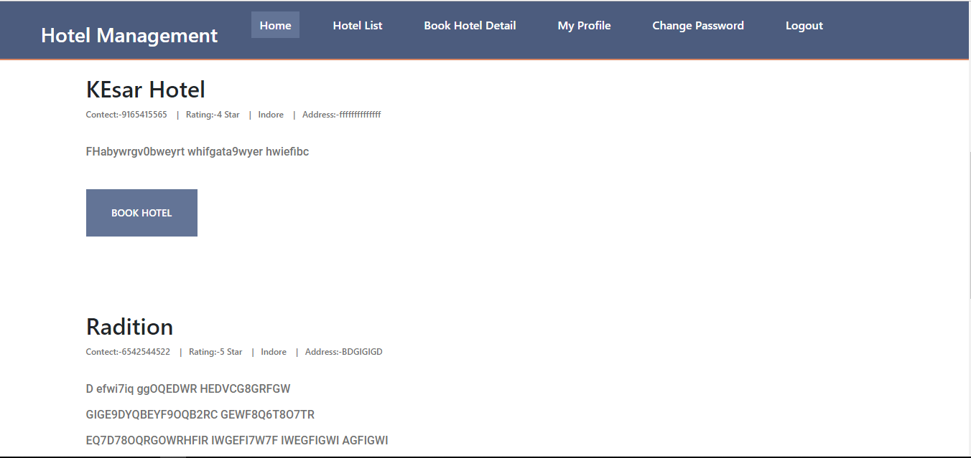

**SourceCode**

<%@page import=*"in.co.hotel.mgt.sys.controller.BookHotelCtl"*%>

<%@page import=*"in.co.hotel.mgt.sys.util.DataUtility"*%>

<%@page import=*"in.co.hotel.mgt.sys.util.ServletUtility"*%>

<%@ page language=*"java"* contentType=*"text/html; charset=ISO-8859-1"*

pageEncoding=*"ISO-8859-1"*%>

<!DOCTYPE html PUBLIC "-//W3C//DTD HTML 4.01 Transitional//EN" "http://www.w3.org/TR/html4/loose.dtd">

<html>

<head>

<meta http-equiv=*"Content-Type"* content=*"text/html; charset=ISO-8859-1"*>

<title>Book Hotel</title>

</head>

<body>

<%@ include file=*"Header.jsp"* %>

<div class=*"home"*>

<div class=*"parallax_background parallax-window"* data-parallax=*"scroll"* data-image-src=*"/HotelManagement/images/blog.jpg"* data-speed=*"0.8"*></div>

<div class=*"home_container"*>

<div class=*"container"*>

<div class=*"row"*>

<div class=*"col"*>

<div class=*"home_content text-center"*>

<div class=*"home_title"*><h1>Book Hotel</h1></div>

</div>

</div>

</div>

</div>

</div>

</div>

<main class=*"login-form"*>

<div class=*"cotainer"*>

<div class=*"row justify-content-center"*>

<div class=*"col-md-8"*>

<div class=*"card"*>

<div class=*"card-header"*>Book Hotel

<b><font color=*"red"*> <%=ServletUtility.getErrorMessage(request)%>

</font></b>

<b><font color=*"Green"*> <%=ServletUtility.getSuccessMessage(request)%>

</font></b>

</div>

<div class=*"card-body"*>

<form action=*"*<%=HMSView.BOOK_HOTEL_CTL%>*"* method=*"post"*>

<jsp:useBean id=*"bean"* class=*"in.co.hotel.mgt.sys.bean.BookHotelBean"*

scope=*"request"*></jsp:useBean>

<% Long hihid=(Long)request.getAttribute("hihd"); %>

<input type=*"hidden"* name=*"htId"* value=*"*<%=hihid%>*"*>

<input type=*"hidden"* name=*"id"* value=*"*<%=bean.getId()%>*"*>

<input type=*"hidden"* name=*"createdBy"* value=*"*<%=bean.getCreatedBy()%>*"*>

<input type=*"hidden"* name=*"modifiedBy"* value=*"*<%=bean.getModifiedBy()%>*"*>

<input type=*"hidden"* name=*"createdDatetime"* value=*"*<%=DataUtility.getTimestamp(bean.getCreatedDatetime())%>*"*>

<input type=*"hidden"* name=*"modifiedDatetime"* value=*"*<%=DataUtility.getTimestamp(bean.getModifiedDatetime())%>*"*>

<div class=*"form-group row"*>

<label for=*"email_address"* class=*"col-md-4 col-form-label text-md-right"*>To Date</label>

<div class=*"col-md-6"*>

<input type=*"text"* id=*"email_address"* class=*"form-control"* name=*"toDate"* value=*"*<%=DataUtility.getStringData(bean.getToDate())%>*"*>

<font color=*"red"*><%=ServletUtility.getErrorMessage("toDate", request)%></font>

</div>

</div>

<div class=*"form-group row"*>

<label for=*"email_address"* class=*"col-md-4 col-form-label text-md-right"*>From Date</label>

<div class=*"col-md-6"*>

<input type=*"text"* id=*"email_address"* class=*"form-control"* name=*"fromDate"* value=*"*<%=DataUtility.getStringData(bean.getFromDate())%>*"*>

<font color=*"red"*><%=ServletUtility.getErrorMessage("fromDate", request)%></font>

</div>

</div>

<div class=*"form-group row"*>

<label for=*"email_address"* class=*"col-md-4 col-form-label text-md-right"*>No. Of Person</label>

<div class=*"col-md-6"*>

<input type=*"text"* id=*"email_address"* class=*"form-control"* name=*"person"* value=*"*<%=DataUtility.getStringData(bean.getNoOfPerson())%>*"*>

<font color=*"red"*><%=ServletUtility.getErrorMessage("person", request)%></font>

</div>

</div>

<div class=*"col-md-6 offset-md-4"*>

<input type=*"submit"* name=*"operation"* class=*"btn btn-primary"* value=*"*<%=BookHotelCtl.OP_SAVE%>*"*>

</div>

</form>

</div>

</div>

</div>

</div>

</div>

</main>

<%@ include file=*"Footer.jsp"* %>

</body>

</html>

**package in.co.hotel.mgt.sys.controller;**

**import java.io.IOException;**

**import javax.servlet.ServletException;**

**import javax.servlet.annotation.WebServlet;**

**import javax.servlet.http.HttpServlet;**

**import javax.servlet.http.HttpServletRequest;**

**import javax.servlet.http.HttpServletResponse;**

**import javax.servlet.http.HttpSession;**

**import org.apache.log4j.Logger;**

**import in.co.hotel.mgt.sys.bean.BaseBean;**

**import in.co.hotel.mgt.sys.bean.BookHotelBean;**

**import in.co.hotel.mgt.sys.bean.HotelBean;**

**import in.co.hotel.mgt.sys.bean.UserBean;**

**import in.co.hotel.mgt.sys.exception.ApplicationException;**

**import in.co.hotel.mgt.sys.exception.DuplicateRecordException;**

**import in.co.hotel.mgt.sys.model.BookHotelModel;**

**import in.co.hotel.mgt.sys.model.HotelModel;**

**import in.co.hotel.mgt.sys.util.DataUtility;**

**import in.co.hotel.mgt.sys.util.DataValidator;**

**import in.co.hotel.mgt.sys.util.PropertyReader;**

**import in.co.hotel.mgt.sys.util.ServletUtility;**

**/\*\***

**\* Servlet implementation class BookHotelCtl**

**\*/**

**@WebServlet(name="BookHotelCtl",urlPatterns={"/ctl/BookHotelCtl"})**

**public class BookHotelCtl extends BaseCtl {**

**private static final long serialVersionUID = 1L;**

**private static Logger log=Logger.getLogger(BookHotelCtl.class);**

**/\*\***

**\* Validate input Data Entered By User**

**\***

**\* @param request**

**\* @return**

**\*/**

**@Override**

**protected boolean validate(HttpServletRequest request) {**

**log.debug("BookHotelCtl validate method start");**

**boolean pass = true;**

**if (DataValidator.isNull(request.getParameter("toDate"))) {**

**request.setAttribute("toDate",**

**PropertyReader.getValue("error.require", "To Date"));**

**pass = false;**

**}**

**if (DataValidator.isNull(request.getParameter("fromDate"))) {**

**request.setAttribute("fromDate",**

**PropertyReader.getValue("error.require", "From Date"));**

**pass = false;**

**}**

**if (DataValidator.isNull(request.getParameter("person"))) {**

**request.setAttribute("person",**

**PropertyReader.getValue("error.require", "No Of Person"));**

**pass = false;**

**}**

**log.debug("BookHotelCtl validate method end");**

**return pass;**

**}**

**@Override**

**protected BaseBean populateBean(HttpServletRequest request) {**

**log.debug("BookHotelCtl populateBean method start");**

**BookHotelBean bean=new BookHotelBean();**

**bean.setId(DataUtility.getLong(request.getParameter("id")));**

**bean.setToDate(DataUtility.getString(request.getParameter("toDate")));**

**bean.setFromDate(DataUtility.getString(request.getParameter("fromDate")));**

**bean.setNoOfPerson(DataUtility.getString(request.getParameter("person")));**

**bean.setHotelId(DataUtility.getLong(request.getParameter("htId")));**

**populateDTO(bean, request);**

**log.debug("BookHotelCtl populateBean method end");**

**return bean;**

**}**

**/\*\***

**\* @see HttpServlet#doGet(HttpServletRequest request, HttpServletResponse response)**

**\*/**

**protected void doGet(HttpServletRequest request, HttpServletResponse response) throws ServletException, IOException {**

**log.debug("BookHotelCtl doGet method start");**

**String op = DataUtility.getString(request.getParameter("operation"));**

**BookHotelModel model = new BookHotelModel();**

**long id = DataUtility.getLong(request.getParameter("id"));**

**long HHId = DataUtility.getLong(request.getParameter("hId"));**

**ServletUtility.setOpration("Add", request);**

**if (id > 0 || op != null) {**

**System.out.println("in id > 0 condition");**

**BookHotelBean bean;**

**try {**

**bean = model.findByPK(id);**

**ServletUtility.setOpration("Edit", request);**

**ServletUtility.setBean(bean, request);**

**} catch (ApplicationException e) {**

**ServletUtility.handleException(e, request, response);**

**return;**

**}**

**}**

**request.setAttribute("hihd", HHId);**

**ServletUtility.forward(getView(), request, response);**

**log.debug("BookHotelCtl doGet method end");**

**}**

**/\*\***

**\* @see HttpServlet#doPost(HttpServletRequest request, HttpServletResponse response)**

**\*/**

**protected void doPost(HttpServletRequest request, HttpServletResponse response) throws ServletException, IOException {**

**log.debug("BookHotelCtl doPost method start");**

**String op=DataUtility.getString(request.getParameter("operation"));**

**BookHotelModel model=new BookHotelModel();**

**long id=DataUtility.getLong(request.getParameter("id"));**

**if(OP_SAVE.equalsIgnoreCase(op)){**

**BookHotelBean bean=(BookHotelBean)populateBean(request);**

**HttpSession session =request.getSession();**

**UserBean uBean=(UserBean)session.getAttribute("user");**

**bean.setUserId(uBean.getId());**

**bean.setUserName(uBean.getFirstName()+" "+uBean.getLastName());**

**try {**

**if(id>0){**

**model.update(bean);**

**ServletUtility.setOpration("Edit", request);**

**ServletUtility.setSuccessMessage("Hotel Booked successfully Updated", request);**

**ServletUtility.setBean(bean, request);**

**}else {**

**long pk=model.add(bean);**

**//bean.setId(id);**

**ServletUtility.setSuccessMessage("Hotel Booked successfully Saved", request);**

**ServletUtility.forward(getView(), request, response);**

**}**

**} catch (ApplicationException e) {**

**e.printStackTrace();**

**ServletUtility.forward(HMSView.ERROR_VIEW, request, response);**

**return;**

**} catch (DuplicateRecordException e) {**

**ServletUtility.setBean(bean, request);**

**ServletUtility.setErrorMessage("Hotel is already exists",**

**request);**

**}**

**}else if (OP_DELETE.equalsIgnoreCase(op)) {**

**BookHotelBean bean= (BookHotelBean)populateBean(request);**

**try {**

**model.delete(bean);**

**ServletUtility.redirect(HMSView.BOOK_HOTEL_LIST_CTL, request, response);**

**} catch (ApplicationException e) {**

**ServletUtility.handleException(e, request, response);**

**e.printStackTrace();**

**}**

**}else if (OP_CANCEL.equalsIgnoreCase(op)) {**

**ServletUtility.redirect(HMSView.BOOK_HOTEL_LIST_CTL, request, response);**

**return;**

**}else if (OP_RESET.equalsIgnoreCase(op)) {**

**ServletUtility.redirect(HMSView.BOOK_HOTEL_CTL, request, response);**

**return;**

**}**

**ServletUtility.forward(getView(), request, response);**

**log.debug("BookHotelCtl doPost method end");**

**}**

**@Override**

**protected String getView() {**

**// TODO Auto-generated method stub**

**return HMSView.BOOK_HOTEL_VIEW;**

**}**

**}**

**package in.co.hotel.mgt.sys.model;**

**import java.sql.Connection;**

**import java.sql.PreparedStatement;**

**import java.sql.ResultSet;**

**import java.util.ArrayList;**

**import java.util.List;**

**import org.apache.log4j.Logger;**

**import in.co.hotel.mgt.sys.bean.HotelBean;**

**import in.co.hotel.mgt.sys.exception.ApplicationException;**

**import in.co.hotel.mgt.sys.exception.DatabaseException;**

**import in.co.hotel.mgt.sys.exception.DuplicateRecordException;**

**import in.co.hotel.mgt.sys.util.JDBCDataSource;**

**public class HotelModel {**

**private static Logger log = Logger.getLogger(HotelModel.class);**

**/\*\***

**\* Find next PK of Role**

**\***

**\* @throws DatabaseException**

**\*/**

**public Integer nextPK() throws DatabaseException {**

**log.debug("Model nextPK Started");**

**Connection conn = null;**

**int pk = 0;**

**try {**

**conn = JDBCDataSource.getConnection();**

**PreparedStatement pstmt = conn.prepareStatement("SELECT MAX(ID) FROM H_Hotel");**

**ResultSet rs = pstmt.executeQuery();**

**while (rs.next()) {**

**pk = rs.getInt(1);**

**}**

**rs.close();**

**} catch (Exception e) {**

**log.error("Database Exception..", e);**

**throw new DatabaseException("Exception : Exception in getting PK");**

**} finally {**

**JDBCDataSource.closeConnection(conn);**

**}**

**log.debug("Model nextPK End");**

**return pk + 1;**

**}**

**public HotelBean findByName(String name) throws ApplicationException {**

**log.debug("Model findBy EmailId Started");**

**StringBuffer sql = new StringBuffer("SELECT * FROM H_Hotel WHERE NAME=?");**

**HotelBean bean = null;**

**Connection conn = null;**

**try {**

**conn = JDBCDataSource.getConnection();**

**PreparedStatement pstmt = conn.prepareStatement(sql.toString());**

**pstmt.setString(1, name);**

**ResultSet rs = pstmt.executeQuery();**

**while (rs.next()) {**

**bean = new HotelBean();**

**bean.setId(rs.getLong(1));**

**bean.setName(rs.getString(2));**

**bean.setCity(rs.getString(3));**

**bean.setAddress(rs.getString(4));**

**bean.setDescription(rs.getString(5));**

**bean.setContect(rs.getString(6));**

**bean.setRating(rs.getString(7));**

**bean.setCreatedBy(rs.getString(8));**

**bean.setModifiedBy(rs.getString(9));**

**bean.setCreatedDatetime(rs.getTimestamp(10));**

**bean.setModifiedDatetime(rs.getTimestamp(11));**

**}**

**rs.close();**

**} catch (Exception e) {**

**log.error("Database Exception..", e);**

**throw new ApplicationException("Exception : Exception in getting User by emailId");**

**} finally {**

**JDBCDataSource.closeConnection(conn);**

**}**

**log.debug("Model findBy EmailId End");**

**return bean;**

**}**

**public HotelBean findByPK(long pk) throws ApplicationException {**

**log.debug("Model findByPK Started");**

**StringBuffer sql = new StringBuffer("SELECT * FROM H_Hotel WHERE ID=?");**

**HotelBean bean = null;**

**Connection conn = null;**

**try {**

**conn = JDBCDataSource.getConnection();**

**PreparedStatement pstmt = conn.prepareStatement(sql.toString());**

**pstmt.setLong(1, pk);**

**ResultSet rs = pstmt.executeQuery();**

**while (rs.next()) {**

**bean = new HotelBean();**

**bean.setId(rs.getLong(1));**

**bean.setName(rs.getString(2));**

**bean.setCity(rs.getString(3));**

**bean.setAddress(rs.getString(4));**

**bean.setDescription(rs.getString(5));**

**bean.setContect(rs.getString(6));**

**bean.setRating(rs.getString(7));**

**bean.setCreatedBy(rs.getString(8));**

**bean.setModifiedBy(rs.getString(9));**

**bean.setCreatedDatetime(rs.getTimestamp(10));**

**bean.setModifiedDatetime(rs.getTimestamp(11));**

**}**

**rs.close();**

**} catch (Exception e) {**

**log.error("Database Exception..", e);**

**throw new ApplicationException("Exception : Exception in getting User by pk");**

**} finally {**

**JDBCDataSource.closeConnection(conn);**

**}**

**log.debug("Model findByPK End");**

**return bean;**

**}**

**public long add(HotelBean bean) throws ApplicationException, DuplicateRecordException {**

**log.debug("Model add Started");**

**Connection conn = null;**

**int pk = 0;**

**HotelBean duplicataRole = findByName(bean.getName());**

**// Check if create Role already exist**

**if (duplicataRole != null) {**

**throw new DuplicateRecordException("Hotel is already exists");**

**}**

**try {**

**conn = JDBCDataSource.getConnection();**

**pk = nextPK();**

**// Get auto-generated next primary key**

**System.out.println(pk + " in ModelJDBC");**

**conn.setAutoCommit(false); // Begin transaction**

**PreparedStatement pstmt = conn.prepareStatement("INSERT INTO H_Hotel VALUES(?,?,?,?,?,?,?,?,?,?,?)");**

**pstmt.setInt(1, pk);**

**pstmt.setString(2, bean.getName());**

**pstmt.setString(3, bean.getCity());**

**pstmt.setString(4, bean.getAddress());**

**pstmt.setString(5, bean.getDescription());**

**pstmt.setString(6, bean.getContect());**

**pstmt.setString(7, bean.getRating());**

**pstmt.setString(8, bean.getCreatedBy());**

**pstmt.setString(9, bean.getModifiedBy());**

**pstmt.setTimestamp(10, bean.getCreatedDatetime());**

**pstmt.setTimestamp(11, bean.getModifiedDatetime());**

**pstmt.executeUpdate();**

**conn.commit(); // End transaction**

**pstmt.close();**

**} catch (Exception e) {**

**e.printStackTrace();**

**log.error("Database Exception..", e);**

**try {**

**conn.rollback();**

**} catch (Exception ex) {**

**throw new ApplicationException("Exception : add rollback exception " + ex.getMessage());**

**}**

**throw new ApplicationException("Exception : Exception in add Role");**

**} finally {**

**JDBCDataSource.closeConnection(conn);**

**}**

**log.debug("Model add End");**

**return pk;**

**}**

**public void delete(HotelBean bean) throws ApplicationException {**

**log.debug("Model delete Started");**

**Connection conn = null;**

**try {**

**conn = JDBCDataSource.getConnection();**

**conn.setAutoCommit(false); // Begin transaction**

**PreparedStatement pstmt = conn.prepareStatement("DELETE FROM H_Hotel WHERE ID=?");**

**pstmt.setLong(1, bean.getId());**

**pstmt.executeUpdate();**

**conn.commit(); // End transaction**

**pstmt.close();**

**} catch (Exception e) {**

**// log.error("Database Exception..", e);**

**try {**

**conn.rollback();**

**} catch (Exception ex) {**

**throw new ApplicationException("Exception : Delete rollback exception " + ex.getMessage());**

**}**

**throw new ApplicationException("Exception : Exception in delete Role");**

**} finally {**

**JDBCDataSource.closeConnection(conn);**

**}**

**log.debug("Model delete Started");**

**}**

**public void update(HotelBean bean) throws ApplicationException, DuplicateRecordException {**

**log.debug("Model update Started");**

**Connection conn = null;**

**HotelBean duplicataRole = findByName(bean.getName());**

**// Check if updated Role already exist**

**if (duplicataRole != null && duplicataRole.getId() != bean.getId()) {**

**throw new DuplicateRecordException("Hotel is already exists");**

**}**

**try {**

**conn = JDBCDataSource.getConnection();**

**conn.setAutoCommit(false); // Begin transaction**

**PreparedStatement pstmt = conn.prepareStatement(**

**"UPDATE H_Hotel SET NAME=?,city=?,address=?,DESCRIPTION=?,contect=?,rating=?,CREATEDBY=?,MODIFIEDBY=?,CREATEDDATETIME=?,MODIFIEDDATETIME=? WHERE ID=?");**

**pstmt.setString(1, bean.getName());**

**pstmt.setString(2, bean.getCity());**

**pstmt.setString(3, bean.getAddress());**

**pstmt.setString(4, bean.getDescription());**

**pstmt.setString(5, bean.getContect());**

**pstmt.setString(6, bean.getRating());**

**pstmt.setString(7, bean.getCreatedBy());**

**pstmt.setString(8, bean.getModifiedBy());**

**pstmt.setTimestamp(9, bean.getCreatedDatetime());**

**pstmt.setTimestamp(10, bean.getModifiedDatetime());**

**pstmt.setLong(11, bean.getId());**

**pstmt.executeUpdate();**

**conn.commit(); // End transaction**

**pstmt.close();**

**} catch (Exception e) {**

**log.error("Database Exception..", e);**

**try {**

**conn.rollback();**

**} catch (Exception ex) {**

**throw new ApplicationException("Exception : Delete rollback exception " + ex.getMessage());**

**}**

**throw new ApplicationException("Exception in updating Role ");**

**} finally {**

**JDBCDataSource.closeConnection(conn);**

**}**

**log.debug("Model update End");**

**}**

**public List search(HotelBean bean) throws ApplicationException {**

**return search(bean, 0, 0);**

**}**

**/\*\***

**\* Search Role with pagination**

**\***

**\* @return list : List of Roles**

**\* @param bean**

**\* : Search Parameters**

**\* @param pageNo**

**\* : Current Page No.**

**\* @param pageSize**

**\* : Size of Page**

**\***

**\* @throws DatabaseException**

**\* @throws ApplicationException**

**\*/**

**public List search(HotelBean bean, int pageNo, int pageSize)**

**throws ApplicationException {**

**log.debug("Model search Started");**

**StringBuffer sql = new StringBuffer("SELECT * FROM H_Hotel WHERE 1=1");**

**if (bean != null) {**

**if (bean.getId() > 0) {**

**sql.append(" AND id = " + bean.getId());**

**}**

**if (bean.getName() != null && bean.getName().length() > 0) {**

**sql.append(" AND NAME LIKE '" + bean.getName() + "%'");**

**}**

**if (bean.getCity() != null && bean.getCity().length() > 0) {**

**sql.append(" AND City LIKE '" + bean.getCity() + "%'");**

**}**

**if (bean.getDescription() != null**

**&& bean.getDescription().length() > 0) {**

**sql.append(" AND DESCRIPTION LIKE '" + bean.getDescription()**

**+ "%'");**

**}**

**}**

**// if page size is greater than zero then apply pagination**

**if (pageSize > 0) {**

**// Calculate start record index**

**pageNo = (pageNo - 1) * pageSize;**

**sql.append(" Limit " + pageNo + ", " + pageSize);**

**// sql.append(" limit " + pageNo + "," + pageSize);**

**}**

**ArrayList list = new ArrayList();**

**Connection conn = null;**

**try {**

**conn = JDBCDataSource.getConnection();**

**PreparedStatement pstmt = conn.prepareStatement(sql.toString());**

**ResultSet rs = pstmt.executeQuery();**

**while (rs.next()) {**

**bean = new HotelBean();**

**bean.setId(rs.getLong(1));**

**bean.setName(rs.getString(2));**

**bean.setCity(rs.getString(3));**

**bean.setAddress(rs.getString(4));**

**bean.setDescription(rs.getString(5));**

**bean.setContect(rs.getString(6));**

**bean.setRating(rs.getString(7));**

**bean.setCreatedBy(rs.getString(8));**

**bean.setModifiedBy(rs.getString(9));**

**bean.setCreatedDatetime(rs.getTimestamp(10));**

**bean.setModifiedDatetime(rs.getTimestamp(11));**

**list.add(bean);**

**}**

**rs.close();**

**} catch (Exception e) {**

**log.error("Database Exception..", e);**

**throw new ApplicationException(**

**"Exception : Exception in search Role");**

**} finally {**

**JDBCDataSource.closeConnection(conn);**

**}**

**log.debug("Model search End");**

**return list;**

**}**

**public List list() throws ApplicationException {**

**return list(0, 0);**

**}**

**/\*\***

**\* Get List of Role with pagination**

**\***

**\* @return list : List of Role**

**\* @param pageNo**

**\* : Current Page No.**

**\* @param pageSize**

**\* : Size of Page**

**\* @throws DatabaseException**

**\* @throws ApplicationException**

**\*/**

**public List list(int pageNo, int pageSize) throws ApplicationException {**

**log.debug("Model list Started");**

**ArrayList list = new ArrayList();**

**StringBuffer sql = new StringBuffer("select * from H_Hotel");**

**// if page size is greater than zero then apply pagination**

**if (pageSize > 0) {**

**// Calculate start record index**

**pageNo = (pageNo - 1) * pageSize;**

**sql.append(" limit " + pageNo + "," + pageSize);**

**}**

**Connection conn = null;**

**try {**

**conn = JDBCDataSource.getConnection();**

**PreparedStatement pstmt = conn.prepareStatement(sql.toString());**

**ResultSet rs = pstmt.executeQuery();**

**while (rs.next()) {**

**HotelBean bean = new HotelBean();**

**bean.setId(rs.getLong(1));**

**bean.setName(rs.getString(2));**

**bean.setCity(rs.getString(3));**

**bean.setAddress(rs.getString(4));**

**bean.setDescription(rs.getString(5));**

**bean.setContect(rs.getString(6));**

**bean.setRating(rs.getString(7));**

**bean.setCreatedBy(rs.getString(8));**

**bean.setModifiedBy(rs.getString(9));**

**bean.setCreatedDatetime(rs.getTimestamp(10));**

**bean.setModifiedDatetime(rs.getTimestamp(11));**

**list.add(bean);**

**}**

**rs.close();**

**} catch (Exception e) {**

**// log.error("Database Exception..", e);**

**throw new ApplicationException(**

**"Exception : Exception in getting list of Role");**

**} finally {**

**JDBCDataSource.closeConnection(conn);**

**}**

**log.debug("Model list End");**

**return list;**

**}**

**}**

#### CONCLUSION

This project is designed to meet the requirements of Online Hotel Management. It has been developed in JSP, Servlets keeping in mind the specifications of the system.

For designing the system we have used simple data flow diagrams. Overall the project teaches us the essential skills like:

* Using system analysis and design techniques like data flow diagram in designing the system.
* Understanding the database handling and query processing.

#### Bibliography

* JAVA Programming E.Balagurusamyl
* JAVA Projects Tony Martin,Dominic Selly
* JAVA Professional Projects Kuljit Kaur,Pooja Bembey
* MY SQL The Complete Reference George Koch